参考：<https://www.suse.com/zh-cn/documentation/sles11/singlehtml/book_sle_admin/book_sle_admin.html>

网络管理

配置默认路由

route add default gw 192.168.1.1

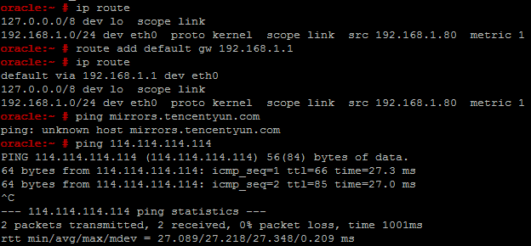

软件包管理

#查看详细的repos

zypper repos -d

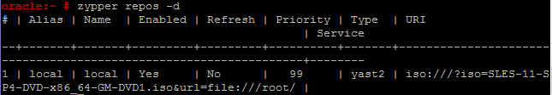

opensuse镜像的zypper源

<http://download.opensuse.org/distribution/leap/42.1/repo/non-oss/>

http://download.opensuse.org/distribution/leap/42.1/repo/oss/

<http://download.opensuse.org/update/42.1/>

http://download.opensuse.org/update/leap/42.1/non-oss/

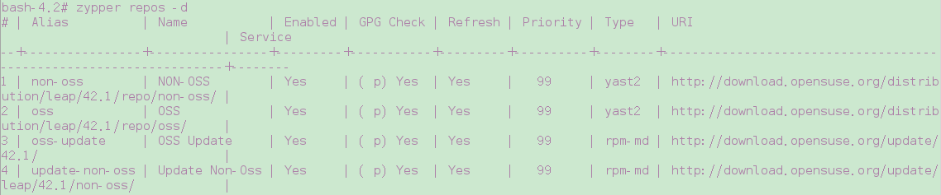

#repos概述

zypper sl

#删除repos

zypper sd suse

通过zypper添加的repos源其实都是/etc/zypp/repos.d/下的配置文件

光盘本地源

/etc/zypp/repos.d/suse11DVD1_1.repo

[suse11DVD1_1]

name=suse11DVD1

enabled=1

autorefresh=1

baseurl=iso:///?iso=SLES-11-SP4-DVD-x86_64-GM-DVD1.iso&url=file:///LTD/

path=/

type=yast2

keeppackages=0

/etc/zypp/repos.d/swyear.repo

[home_swyear]

name=swyear's Home Project (SLE_11_SP3)

type=rpm-md

baseurl=http://download.opensuse.org/repositories/home:/swyear/SLE_11_SP3/

gpgcheck=0

gpgkey=http://download.opensuse.org/repositories/home:/swyear/SLE_11_SP3//repodata/repomd.xml.key

enabled=1

/etc/zypp/repos.d/sohu.repo

[sohu]

name=sohu

enabled=1

autorefresh=1

baseurl=http://download.opensuse.org/repositories/openSUSE:/11.4:/Update/standard/

gpgcheck=0

gpgkey=http://download.opensuse.org/repositories/openSUSE:/11.4:/Update/standard/repodata/repomd.xml.key

type=rpm-md

keeppackages=0

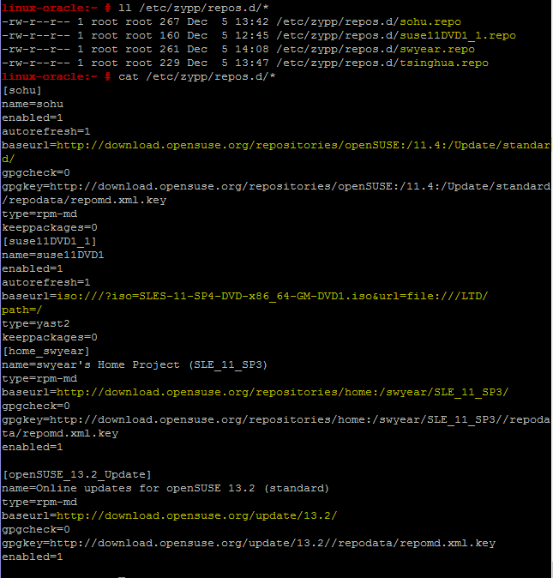

注意：suse的软件包源参差不一，很难保证一致性！！

zypper info mysql

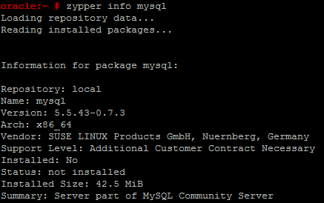

命令参考：

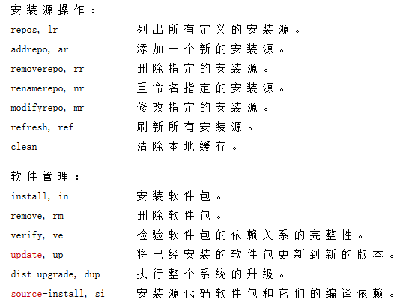

安装oracle11g

#创建oracle用户和组

groupadd oinstall

groupadd dba

useradd -g oinstall -g dba -m oracle

#这些修改与否实际上意义不大

echo 'kernel.sem = 250 256000 100 1024' >> /etc/sysctl.conf

echo 'net.ipv4.ip_local_port_range = 5000 65500' >> /etc/sysctl.conf

#其他的都保持默认，一定要声明安装的语言环境和安装时使用的语言，避免闪退

echo export NLS_LANG=AMERICAN_AMERICA.ZHS16GBK >> /home/oracle/.bashrc

echo export LANG=AMERICAN_AMERICA.ZHS16GBK >> /home/oracle/.bashrc

source /home/oracle/.bashrc

#如果不知道需要什么软件包，裸装会有提示，以下都是按提示所得

zypper install gcc gcc-32bit gcc-c++ glibc-devel glibc-devel-32bit libaio-devel libaio-devel-32bit libstdc++43-devel libstdc++43-devel-32bit libstdc++-devel sysstat

#注销root以oracle用户登录GNOME桌面，开始安装

